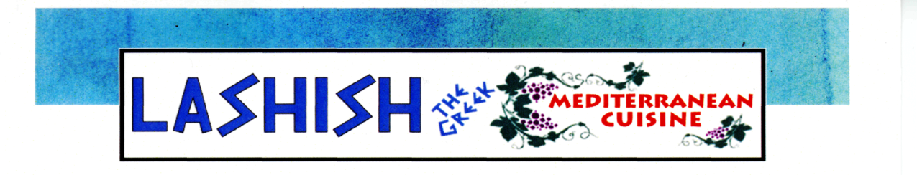
APPETIZERS
(V) : denotes vegetarian item extra pita available for $0.50 each
Hummus (V) Small (2 pitas) 4.99 Large (3 pitas) 6.95
A blend of ground chickpeas and tahini sauce combined with lemon juice and topped with extra virgin olive oil Served with pita bread for dipping.
Baba Ghanoush (V) Small (2 pitas) 4.99 Large (3 pitas) 6.95
Roasted eggplant, tahini sauce, light garlic, parsley, and topped with extra virgin olive oil Served with pita bread for dipping.
Tzatziki (V) ......................................................................................................... (2 pitas) 5.95
Afresh, light dish containing yogurt, cucumber, dill, mint, lemon juice, and garlic. Served with pita bread for dipping.

Dolmadakia (V) .................................................................................................................. 3.99
Grape leaves stuffed with rice, tomato, parsley, green onion, lemon juice, Lashish’s herbs, and olive oil - cooked to perfection!
Falafel (V) ........................................................................................................... (4 pieces) 3.25
Ground chickpeas, onion, cilantro, parsley, and a blend of LaShish herbs and spices, shaped into tasty patties then fried. Served with a side of LaShish’s special tahini sauce.
Spanakopita (spinach pie) (V) ............................................................................................ 3.95
Prepared with phyllo dough, fresh spinach, feta cheese, dill, and LaShish’s herbs. Baked to perfection!
Kibbeh (1 piece) ............................................................................................................... 3.50
Made with cracked wheat and lean meat shell. Filled with ground lamb, beef, light onion, and pine nuts, then fried. Served with LaShish’s special tahini sauce.
Fried Smelts ....................................................................................................................... 6.95
Lake Michigan smelts, lightly breaded and fried. Served with Greek sauce.
Fried Calamari ................................................................................................................... 7.99
Tender, mouth-watering squid lightly floured and fried. Served with Greek sauce.
Combo Appetizer Platter (for one person) (V) 9.99
Hummus, baba ghanoush, dolmadakia (2),falafel (2), and served with 2 pitas for dipping.
LASHISH SOUPS
Chicken Lemon Soup .3.95
Lentil Vegetable Soup .3.95
Soup of the Day (when available) .3.95
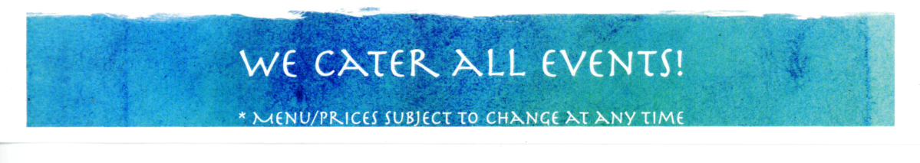

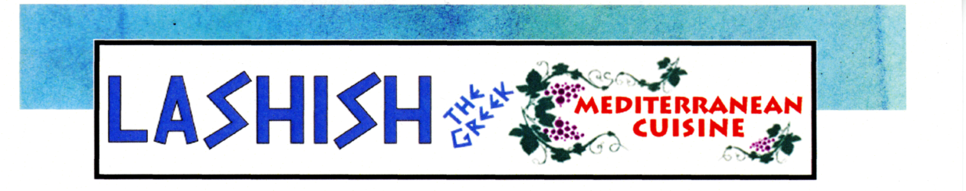
LASHISH SALADS
(V): denotes vegetarian dish
Tossed Salad (V) 5.95
Fattoush Salad (V) .......................................................................................................... 6.99
A blend of romaine lettuce, tomatoes, cucumbers, bell peppers, and radishes mixed with LaShish’s special herbs, a lemon/vinegar blend, and extra virgin olive oil
Tabbouleh Salad (V) ....................................................................................................... 7.99
Finely chopped parsley, tomatoes, fresh mint, and green onions mixed with bulgur (cracked wheat),
then topped with LaShish’s special herb blend, lemon juice, and extra virgin olive oil
Greek Salad (V) ................................................................................................... ........... 6.99
Mixed romaine & iceberg lettuce, with black Kalamata olives, Bermuda onions, tomatoes, banana peppers, bell peppers, and feta cheese. Served with our famous Greek herb dressing.
Shepherd Salad (V) ........................................................................................... ............. 7.95
A delightful blend of cucumbers, peppers, banana peppers, tomatoes, onions, feta cheese, and olives.
ENTRÉE GREEK SALADS
served with one pita
Gyro Salad 12.99
Kafta Salad 12.99
Falafel Salad (V) 5 pieces of falafel 11.99
Grilled Chicken Salad 12.99
Blackened Grouper Salad 12.95
Grilled or Blackened Salmon Salad 14.99
Fried Calamari Salad 13.99
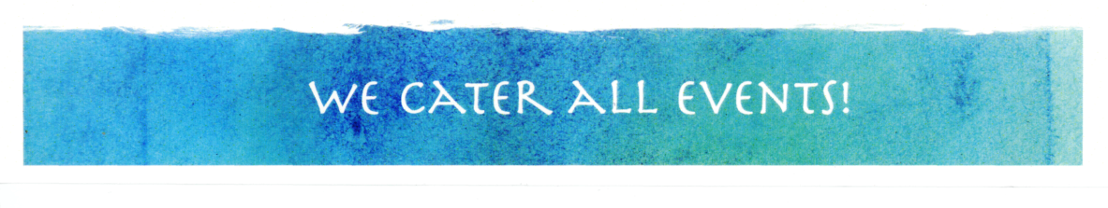

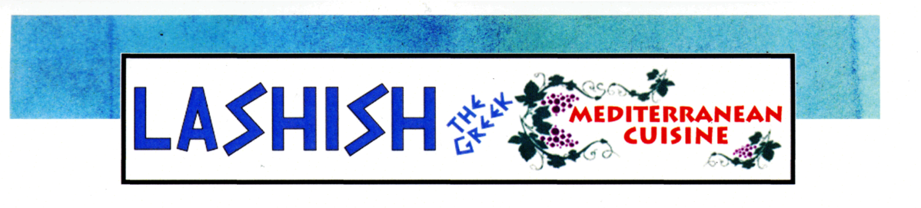
TRADITIONAL MEDITERRANEAN
DISHES
Pastitsio 11.99
Greek style pasta, layered with meat and tomato sauce, topped with Bechamel Romano
sauce and baked to perfection.
Moussaka 12.99
Layered eggplant and potatoes with meat and tomato sauce topped with Bechamel
Romano sauced and baked to perfection
Chicken Lemonato 12.99
Grilled chicken breast marinated in herbs topped with a lemon sauce
Grecian Chicken 12.99
Served with rice and fresh vegetables
Gyro Dinner (gyro meat or chicken) 12.99
Served with rice over Greek salad
KABOBS
served with Mediterranean rice and fresh vegetables
Kafta Kabob (2) . 12.99
Chicken Kabob . 12.99
Shish Kabob .. 14.99
Lamb Kabob .. 14.99
Lamb Chops .. 18.99
LaShish Mixed Grill Combo .. 17.99
Four pieces of both shish and chicken kabob, one skewer kafta kabob
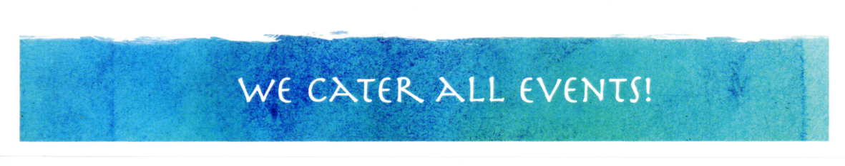

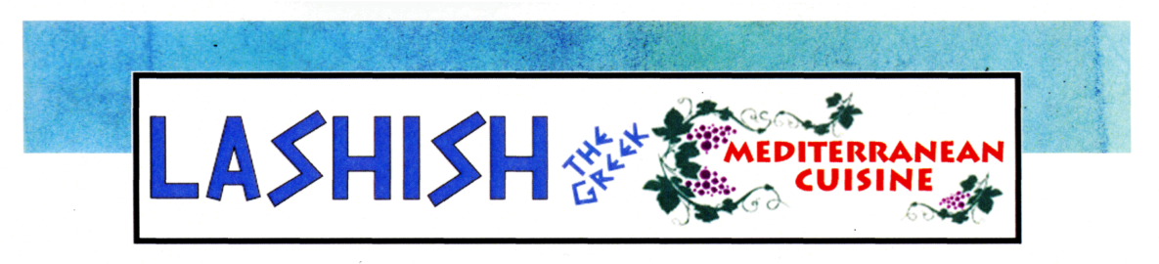
SEAFOOD
all seafood dishes are served with Mediterranean rice and fresh vegetables, or over a Greek salad
(V): denotes vegetarian dish
Lemon Sole 13.99
Key Lime Red Snapper 13.95
Grilled or Blackened Salmon 14.99
Blackened Grouper 13.99
LASHISH PLATTERS
with fattoush salad, hummus, and pita bread
Kibbeh Dinner (2) . 12.99
Falafel Dinner (V) .. 11.99
Shawarma Dinner Platter . 12.99
Vegetarian Dinner . 12.99
(3 grape leaves, 3 falafel)
COMBO DINNERS
choose one side: small tossed salad, french fries, rice, or soup
LaShish Gyro (with gyro meat or chicken) 9.99
Falafel Pita .. 9.99
Shawarma Pita 9.99
Hamburger .. 9.99
GOURMET FRENCH FRIES
A taste to remember! Replace French Fries with Greek Fries or Cajun Fries for $1.00 extra
Greek Fries . 3.50
Cajun Fries 3.50
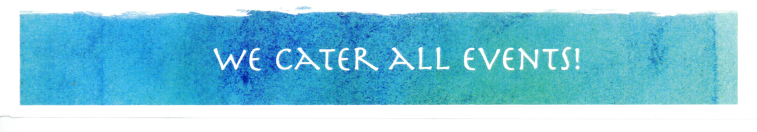

ADD TO YOUR MEAL
French Fries 2.50
Greek Fries 3.50
Small Salad (Tossed or Greek) 4.99
Pita (per piece) 0.75
Cajun Fries 3.50
Fresh Vegetables 2.25
Rice 2.75
Gyro Meat 5.99
Skewer of Chicken Kabab 8.99
Skewer of Kafta Kabab 7.99
Skewer of Shish Kabab 9.99
Feta Cheese 0.99
Olives 0.99
KIDS MENU
ages 6 and under
Gyro Sandwich with French Fries 4.95
Pizza with Mozzarella Cheese 4.95
Fried Chicken Strips w/ French Fries 4.95
HOME-MADE DESSERTS
N.Y. Cheesecake 5.95
Tiramisu 5.50
Chocolate Cake 4.95
Baklava (1 piece) 1.95
Kourabiethes (1 piece) (powdered sugar almond cookies) 1.45
Rizogalo (rice pudding) 3.95
Galaktobouriko (Greek custard stuffed pastry) 4.95
DRINKS
Soft Drinks 1.95
Coca-Cola, Diet Coke, Sprite, Root Beer, Pink Lemonade)
Red Bull/Snapple .2.95
Regular Coffee 1.75
Turkish Coffee (no refills) 2.95
Turkish Hot Tea 2.25
Iced Tea 1.95
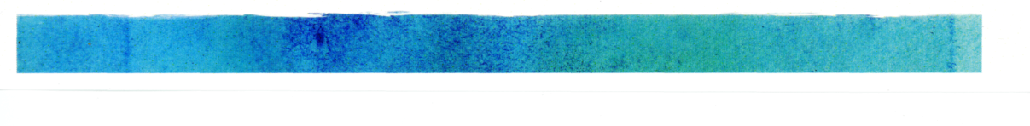

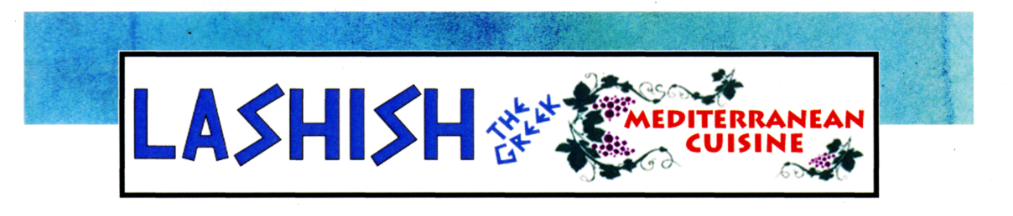

CATERING
OFFERING SOLUTIONS FOR ALL EVENTS & BUDGETS:
*BOX LUNCHES *BIRTHDAYS
*HOLIDAY PARTIES
*FAMILY REUNIONS *WEDDINGS
*MAJOR EVENTS
WE HAVE FOOD EVERYONE WILL ENJOY!

*All prices are subject to change without notice

